APA Referencing Style

In-text example



Referencing List Example

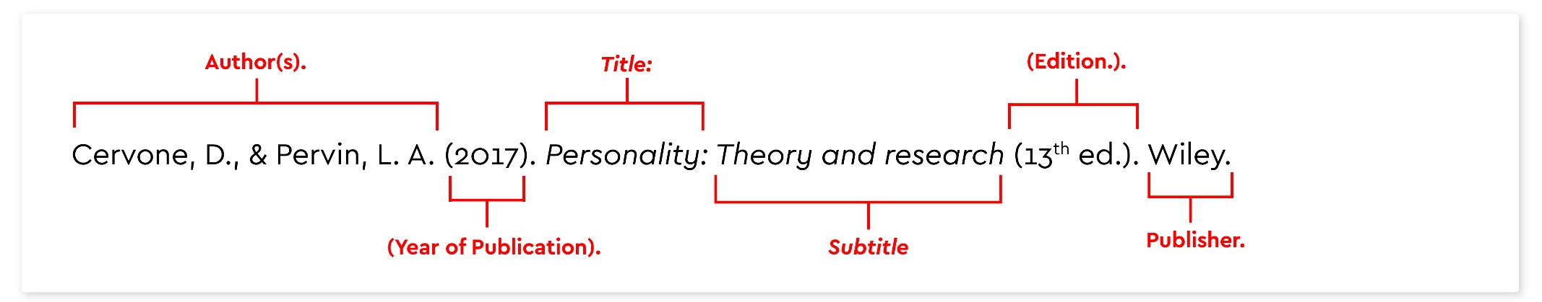

Books

Material Type | In Text Citation | Reference List Entry
Book | (Wells, 2009, pp. 225-226) | Wells, A. (2009). Metacognitive therapy for anxiety and depression in psychology. Guilford Press.
Book:  Two Authors | (Colcough & Colcough, 1999, p. 20) | Colclough, B., & Colclough, J. (1999). A challenge to change. Thorsons.
Book:  Multiple authors | (Rosenthal et al., 2000, p. 1) | Rosenthal, R., Rosnow, R. L., & Rubin, D. B. (2000). Contrasts and effect sizes in behavioral research: A correlational approach. Cambridge University Press.
Book:  No Author | (The Blackwell Dictionary of Cognitive Psychology, 1991, p.1000) | The Blackwell dictionary of cognitive psychology. (1991). Blackwell.
Book: Editor | (Snyder, 1999, p. 1) | Snyder, C. R. (Ed.). (1999). Coping: The psychology of what works. Oxford University Press.
Book:  2 or More Editors | (Binstock & George, 1990, p. 10) | Binstock, R. H., & George, L. K. (Eds.). (1990). Handbook of aging and the social sciences (3rd ed.). Academic Press.
E-books

Material Type | In Text Citation | Reference List Entry
E-book | (Eckes, 2000) | Eckes, T. (2000). The developmental social psychology of gender. Lawrence Erlbaum Associates. https://prospero.murdoch.edu.au:443/record=b1600608
Chapter from an E-book | (Jones & Gagnon, 2007) | Jones, N. A., & Gagnon, C. M. (2007). The neurophysiology of empathy. In T. F. D. Farrow & P. W. R. Woodruff (Eds.), Empathy in mental illness. Cambridge University Press. https://prospero.murdoch.edu.au:443/record=b2130403
E-journals

Material Type | In Text Citation | Reference List Entry
Journal Article with a DOI | (Vogels, 2009, p. 112) | Vogels, A. G. C., Crone, M. R., Hoekstra, F., & Reijneveld, S. A. (2009). Comparing three short questionnaires to detect psychosocial dysfunction among primary school children: a randomized method. BMC Public Health, 9, 489. https://doi.org/10.1186/1471-2458-9-489
Journal Article with a URL | (Ahmann, 2018, p. 10) | Ahmann, E., Tuttle, L. J., Saviet, M., & Wright, S. D. (2018). A descriptive review of ADHD coaching research: Implications for college students. Journal of Postsecondary Education and Disability, 31(1), 24-58. https://www.ahead.org/professional-resources/publications/jped/archived-jped/jped-volume-31
Journal Articles

Material Type | In Text Citation | Reference List Entry
Journal Article in Print | (Parker & Roy, 2001, p. 574) | Parker, G., & Roy, K. (2001). Adolescent depression: A review. Australian and New Zealand Journal of Psychiatry, 35, 572-580.
Journal Article in Print with 3-20 Authors | (Zhang et al., 2006, p. 10) | Zhang, B., Cohen, J., Ferrence, R., & Rehm, J. (2006). The impact of tobacco tax cuts on smoking initiation among Canadian young adults. American Journal of Preventive Medicine, 30(6), 474-479.

